Cult Leaders/ Members
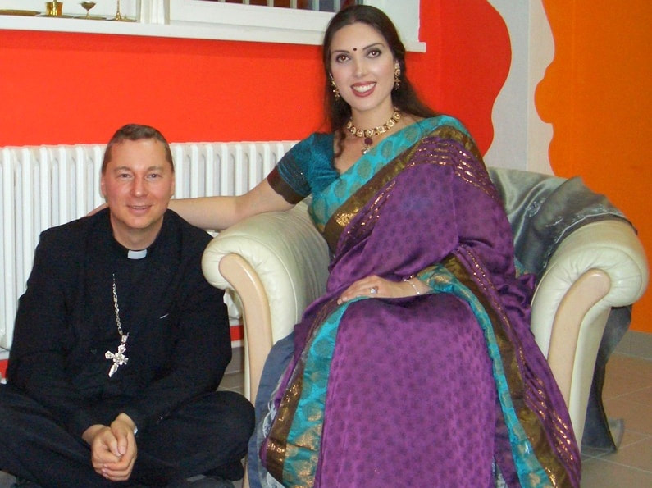 | Sarah Landry  Cult leader of One in God movement  Implant to steal the steal the Hindu science of power manifestation  Pedophile who raped and tortured a student of the indigenous school who after being rescued exposed her diabolical intentions  When the attempt to steal failed, she and her cult members spread hate speech and disinformation on social media and deep state controlled television channels to try to delegitimize and destroy the ancient science and the AIAT
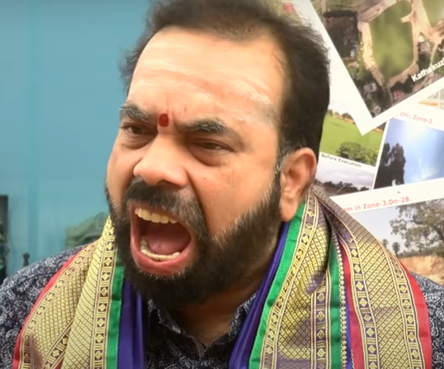 | Janardhan Sharma  Pedophile who abused his own minor daughters  Implant who tried to do economic fraudulence in the AIAT monastery  When exposed, he in cohorts with the deep state electronic and print media ran a malicious hate campaign against the AIAT and spread disinformation against the SPH through vilification of the science of power manifestation, gender shaming of the SPH and His women followers, calling the SPH enemy of the State, lawfare, inciting the destruction of the largest only-women AIAT monastery.
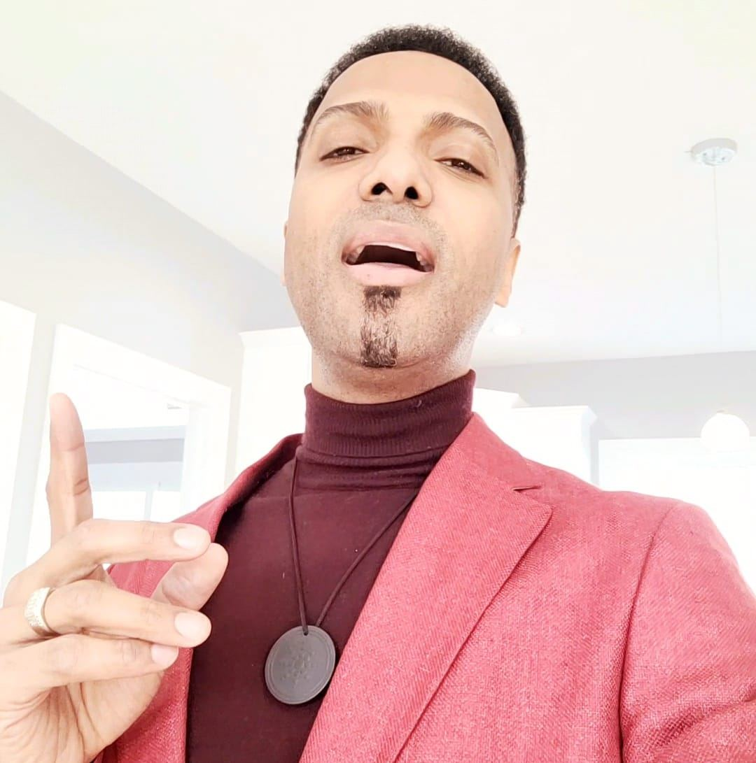 | Steven Hodge  Cult member  Spread hate speech and disinformation against the SPH and AIAT to make them targets of mob lynching and defame and destroy the science of power manifestation, and targeted abuse against the women and girl children of AIAT
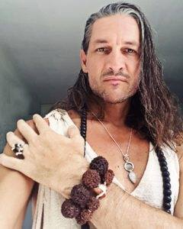 | Satyojata  Cult member  Implant who showed himself as a follower of Hinduism and then did U turn to abuse Hindu principles, tradition and teachings
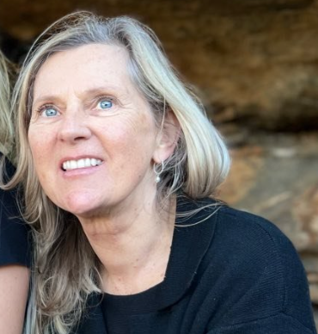 | Marion Braun  Cult member  Propagated disinformation in social media to destroy the only women’s AIAT monastery and spread hate speech to incite mob violence against AIAT especially women
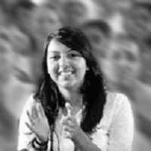 | Trisha Singh  Cult member  Infiltrated the AIAT community as a student of Hinduism and then did U turn and defamed the AIAT lifestyle and monastic vows
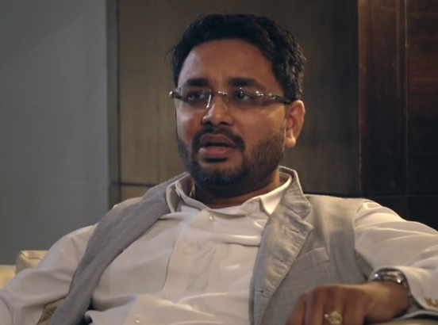 | Kashyap Jani, politician  Deep state element spreading hate against AIAT, the SPH by defaming them as a cult and supporting pedophiles like Janardhan Sharma

https://www.facebook.com/luke.vieira.1/posts/3062376210549122

